MISA MRM Service Design Workbench User’s Guide

Introduction 1
General Capabilities 2
1. Creating a municipal model from the MRM 2
2. How municipalities access their municipal models 3
3. Providing End-User Guidance 5
4. Viewing and editing the municipal model with role-specific viewpoints 9
5. Searching for model elements 14
6. Editing model elements 15
7. Editing relationships using matrices 18
8. Displaying related model elements 20
9. Using Diagrams 20
10. Controlling model elements and relationship displayed in diagrams 21
11. Creating Hierarchy Diagrams 22
12. Querying, validating, and reporting on model content 22
13. Creating and Applying Analytics and Heat Maps 23
14. Publishing the municipal model 24
15. Publishing MRM method work products 25
16. Customizing the metamodel 26
17. Backing up and restoring a municipal model 26
18. Managing User Access 26
Access to the SDW 27
Encyclopedia Access 27
Enterprise Encyclopedia Access 28
Collaboration Site Access 28
Municipal model versioning and lifecycle management 29

Introduction
A significant amount of information useful to municipal stakeholders exists in the form of printed documents, spreadsheets, diagrams, etc. This information is very valuable, but leveraging this value is challenged by having the content in a form that is difficult to access, extend and integrate, as well as developed using different vocabularies. The MRM provides a common vocabulary and comprehensive municipal model content that evolved out of harvesting these diverse documents into a common, proven framework.

The Service Design Workbench (SDW) described in this User’s Guide provides an effective means of defining, extending, integrating and sharing the municipal reference models, and instantiations of those models for specific municipalities. SDW provides a collaborative environment in which public sector or municipal models can be created, validated, communicated across a wide range of stakeholders, reasoned about and acted upon to deliver value to target groups. It produces reports and work products that support different stakeholder viewpoints in order to address different concerns.

The SDW User’s Guide is intended to summarize SDW capabilities that support the MRM method as described in its business use cases, tasks, activities and functions. The sections below describe general capabilities that would be applicable to various municipal modeling activities.

General Capabilities

Creating a municipal model from the MRM
The MRM is a reference model that represents a reusable asset capturing best practices for public sector or municipal governance business architecture. Each municipality that uses the MRM will create an instance municipal model from the MRM and will customize that instance for their particular needs.
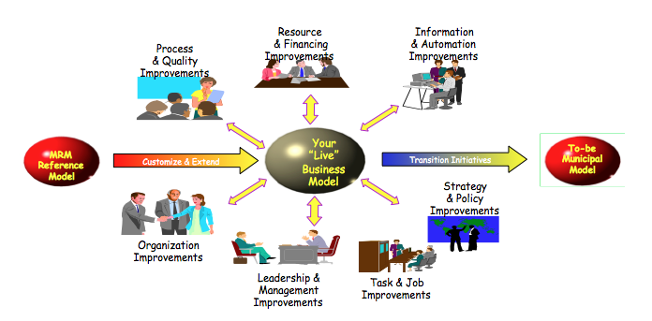
To create an instance of the MRM for your use, perform the following steps:

  - Access an backup of the MRM database from MISA
- The MRM database backup could be accessed by a RAM server over the Web
- The MRM asset could be stored in a version management system in order to support lifecycle management and governance
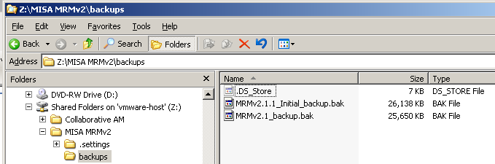
  - Open the SAEM and connect to the municipal System Architect database server
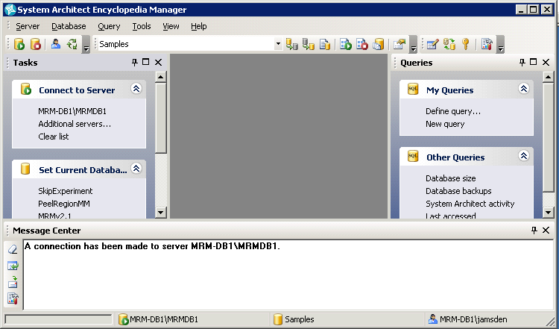
  - Create a new encyclopedia database from the MRM backup file, navigating to the MRM backup file obtained from MISA
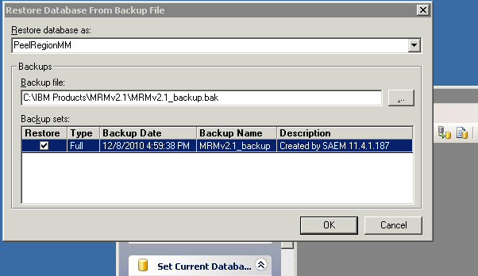
This municipal model, for example, Gotham City, is created from the MRMv2.1 reference model on the local machine where the SA client is running. This represents an instance of the MRM for Gotham City.

How municipalities access their municipal models
The municipal model is a shared resource among the business users and analysts who will be developing, communicating, validating, reasoning about and acting upon information captured in the model. These users must have controlled access to the shared resource in a manner that provides proper authentication and access control, role-specific viewpoints, efficient access, versioning and support for parallel development.

Rational System Architect provides a number of facilities that support these requirements including:
- A distributed, multi-user database server with full authentication and access control using the System Architect Catalog Manager
- The ability for multiple System Architect rich client applications to attach to a shared database in the same LAN (not WAN).
- The ability to access different System Architect clients that share a database server in the same LAN, possibly in a Cloud, through virtual desktops or Remote Desktop Connection
- The ability to access a shared enterprise encyclopedia database from a Web browser in a LAN or WAN using SA/XT
- The ability to have local installations of System Architect with their own local encyclopedias with more controlled municipal models.
- The ability to detach a database from a remote server and attach it to a local server for more focused, higher performance and localized collaboration
- The ability to checkout portions of a shared model into a local encyclopedia to do independent, possibly disconnected work and checking the results at some later time, while avoiding the possibility of collisions
- The ability to work in different workspaces on the same shared municipal models and to compare and merge the contents of different workspaces for lifecycle management

A typical way for multiple users located in different geographies is to exploit a Cloud environment. Each user has access to a separate virtual image that has System Architect installed. There is another virtual image in the same Cloud that has the encyclopedia database installed and runs the database server. The users access the virtual images through a Remote Desktop Connection (RDC). The users can have their own encyclopedia, or share the same team encyclopedia in the same Cloud.

- Login to the your virtual image in the Cloud using the URI for the virtual machine and your credentials (userid and password).
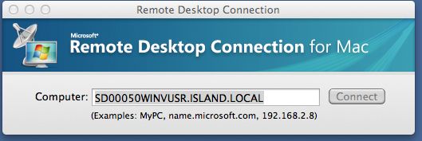
- Start System Architect and create a connection to the shared database
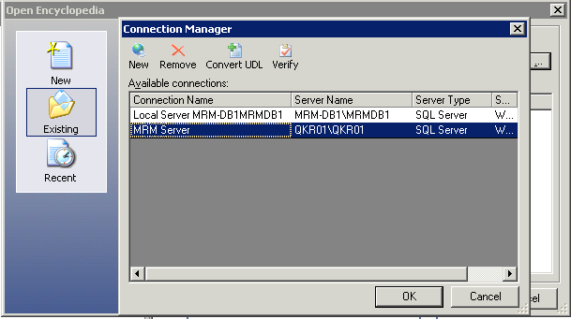
This dialog shows two database connections, one for the for the local database running on the same image as the SA client, and a shared database server called MRM Server. Your server configuration may be different.
- Using the database connection, open the municipal model for a particular municipality.
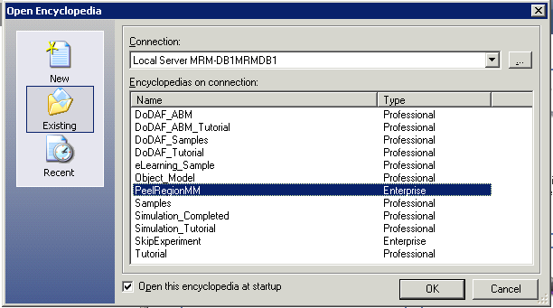

Providing End-User Guidance
There are many stakeholders that participate in the development of a municipal model, and use that model in strategic planning, solution delivery and municipal governance. Many of these users will have only occasional use of the MRM and its supporting tools, and will need guidance for how to perform activities that address their needs and concerns.

Rational System Architect supports frameworks to help users navigate specific methods. The Framework Browser enables you to view and access the models and artifacts you have developed in a System Architect encyclopedia through a framework interface. Each cell of the framework can be opened, to view a filtered browser list of all diagrams and definitions in the encyclopedia that pertain to that cell of the framework.

System Architect also provides Guide Books that help users perform specific tasks within a framework. A guide book is a set of HTML pages integrated with System Architect that describe the best practices and steps required to perform tasks that may be specific to the chosen framework, or general purpose. Links in the guide book pages can perform System Architect menu commends, opening browsers, matrices, running reports, opening diagrams, creating new model elements, etc. These guidebooks help inexperienced or infrequent users make the best use of the SDW.

System Architect also has an extensible help system that can be extended with method and metamodel specific information.

- Start System Architect and open the Gotham City encyclopedia
- Users can select different encyclopedias for different projects
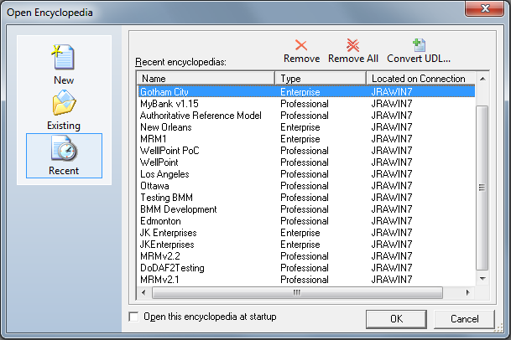
- Use File > Edit Framework to select the desired framework, and File > Show Framework to open the framework window
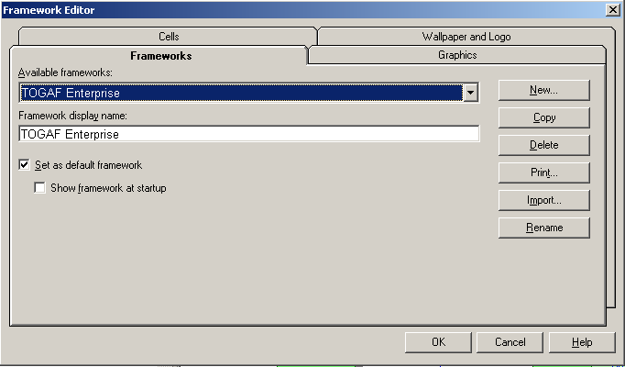
- TOGAF is an example framework and the framework steps.
- Click on a step in the framework to open the explorer and/or matrix browsers that support activities in that step
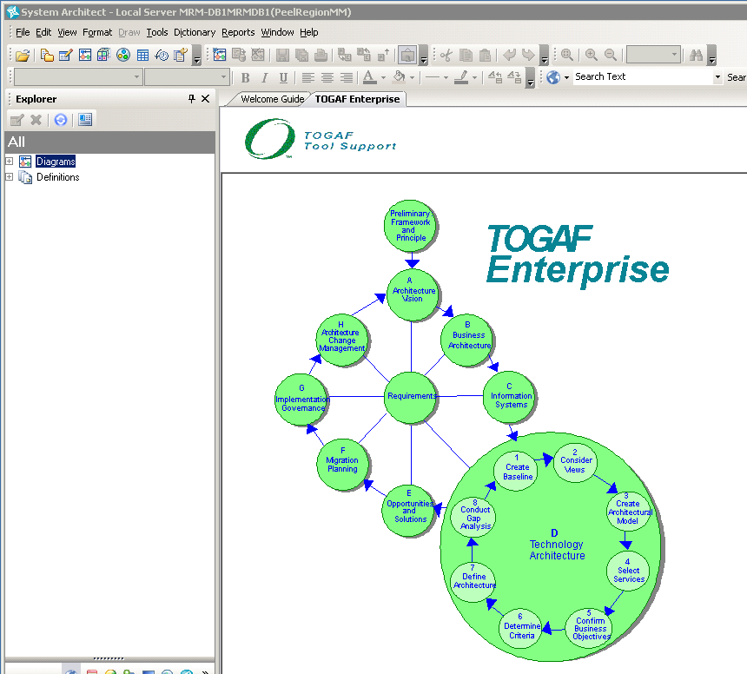
- The System Architect Welcome Guide is an example guidebook that helps guide users through common activities. Use File > Show Welcome Guide to open the welcome guide window
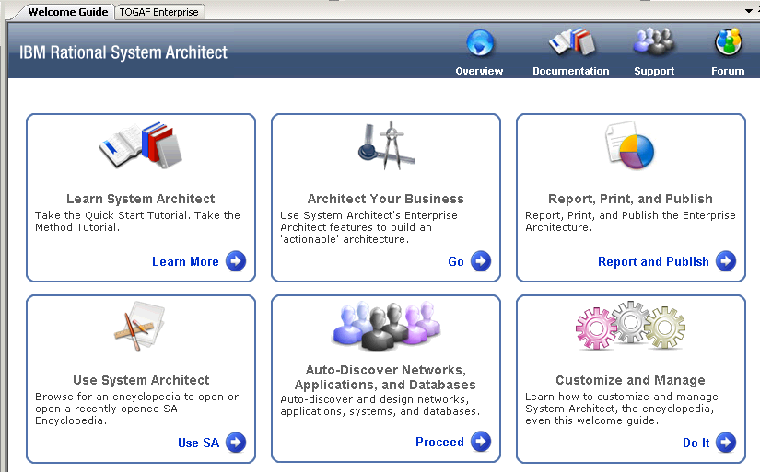
- Click on the “Architect Your Business” step, then “Build an Enterprise Architecture”
- Links in the guidebook can invoke System Architect functionality
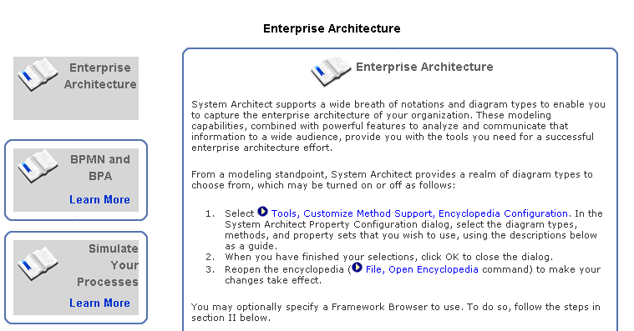
- Specific guidebooks could be created that support MRM activities
- On-line help is available and can be customized for specific methods
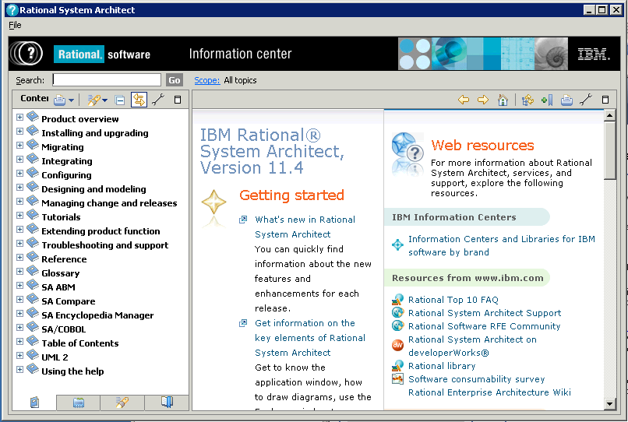

Viewing and editing the municipal model with role-specific viewpoints
The many stakeholders involved in municipal business architectures and strategic planning may play different roles and have different concerns. Each of these roles may have a preferred viewpoint through which they access and manipulate the municipal models in order to address their concerns.

System Architect supports these viewpoints through:
- Role-specific activities in a framework
- Specific sections in guide books that support the activities of a given role
- Specific static or dynamic Explorer browsers that contain the diagrams and definitions that are of interest to the stakeholder playing a specific role
- Specific Matrix browsers that organize matrices for editing relationships between model elements by role
- Explorer Object and Explorer Relationship reports can be used to create role-specific diagrams for exploring model elements, navigating related elements and performing impact analysis
- Specific Analytic Collections for performing analysis and creating heat maps that address specific stakeholder concerns
- Diagram and symbol formats (pen, line, fill color, text font, etc.) can be used to create stakeholder-specific views and stored in format files.
- Report files that organize reports by role

- Recall that frameworks provide views for specific activities
- Recall that guidebooks provide guidance and active links in support of specific activities page
- The MRM Explorer Browser provides access to specific MRM diagrams and definitions.
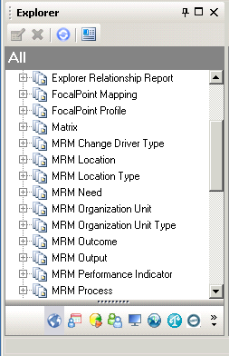
- Users can create their own views by clicking on the Add new pane button
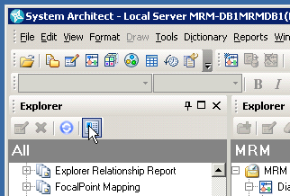
- Create a new View definition to specify which definitions and diagrams should be included in the Explorer pane
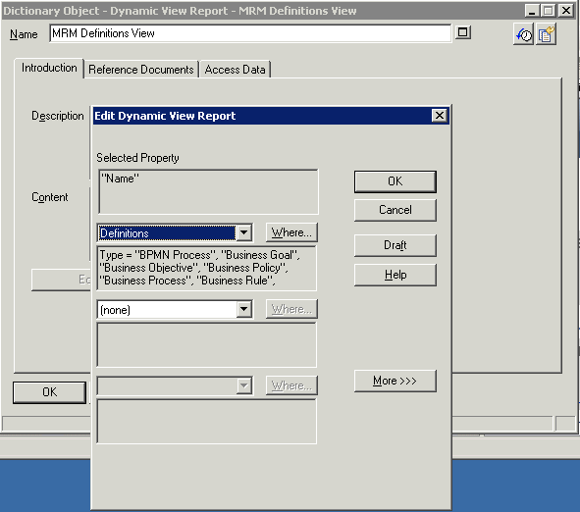
- Drag and drop the view definition into the newly created Explorer pane to configure what will be shown in that pane
- The MRM Matrix Browser shows the matrices that are available to view and edit relationships between MRM model elements
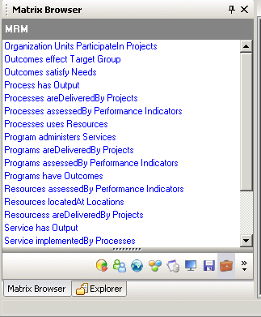
- Different MRM Matrix Browsers can be created for different MRM roles, showing only the relationships that are applicable to that role
- Users can create their own user-defined matrices using Tools > Matrix Designer
- Explorer diagrams can be created for different stakeholders and used to navigate relationships and do impact analysis as well as address other concerns.
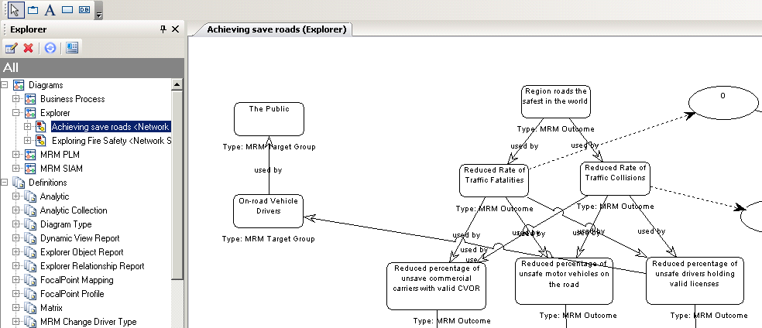
- The MRM reports are defined in a specific report file.
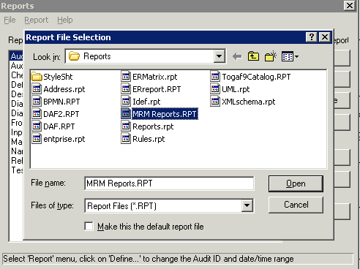
- Reports can be organized in different report files to support different roles
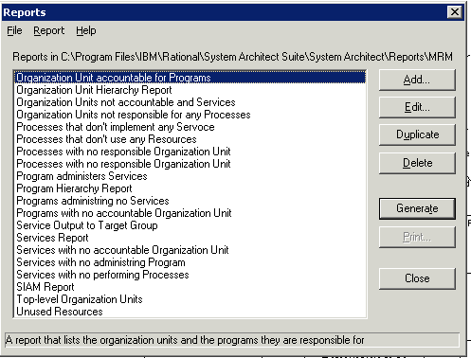
- Users can add their own reports organized into report files as they wish
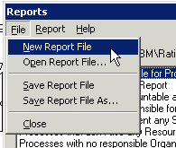
- Analytic Collections and the Heat Map Manager can be used to address specific stakeholder concerns
- Users can apply selected analytics and see results depicted on diagrams
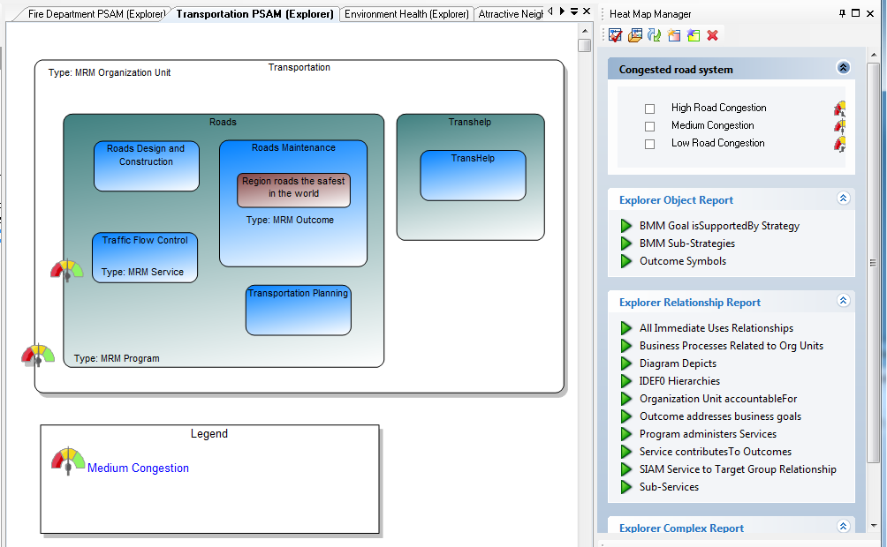

Searching for model elements
Users can search for model elements, diagrams, symbols or definitions, whose properties match the specified criteria. The result of the search is displayed in a view where the user can double-click on any matching element to open and view or edit that element. The queries used in Search are essentially the same as the ones used to generate reports.

- Enter text into the Search toolbar field and press the Search button
- A report shows the model elements that match the search string
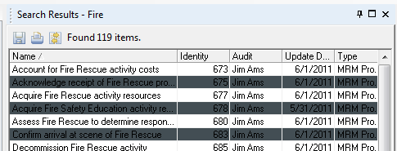
The search can be filtered by diagrams and symbols, definitions only, or all model elements.
- Alternatively, open the Advanced search dialog to perform a search
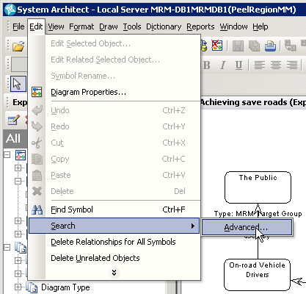
- Here is an example of a search for all MRM Services whose name starts with “Fire”
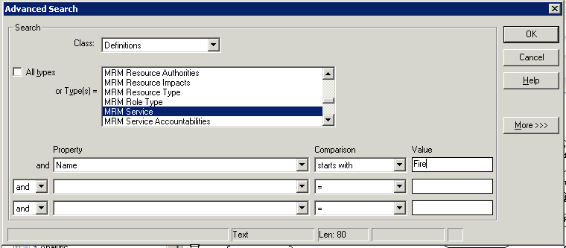
- Double-click on one of the found services to see its definition
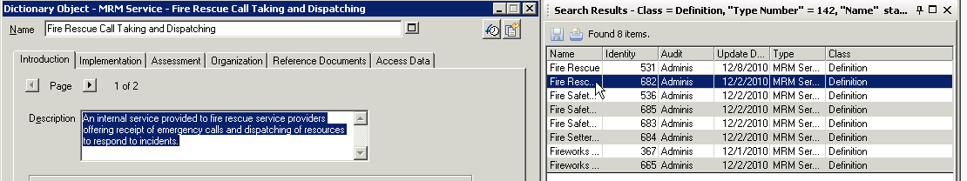

Editing model elements
Definitions are model elements in System Architect that represent instances of the MRM metamodel that defines the encyclopedia. All definitions are created, edited, searched, navigated, reported on, etc. the same way.

Definitions are edited by double clicking on the name of the definition in many places that it appears in System Architect views and diagrams. The properties of the definition are displayed in a dialog organized by tabs, pages, and rows and columns within a page. Tabs organize related properties. Pages are used within a tab if there are more properties than can be displayed in one page. Properties can then be organized in row/column grids with grouping, labels and input fields.

- Open the Fire Rescue service.
- Typing characters in the Explorer view scrolls to the definition or diagram with the matching name
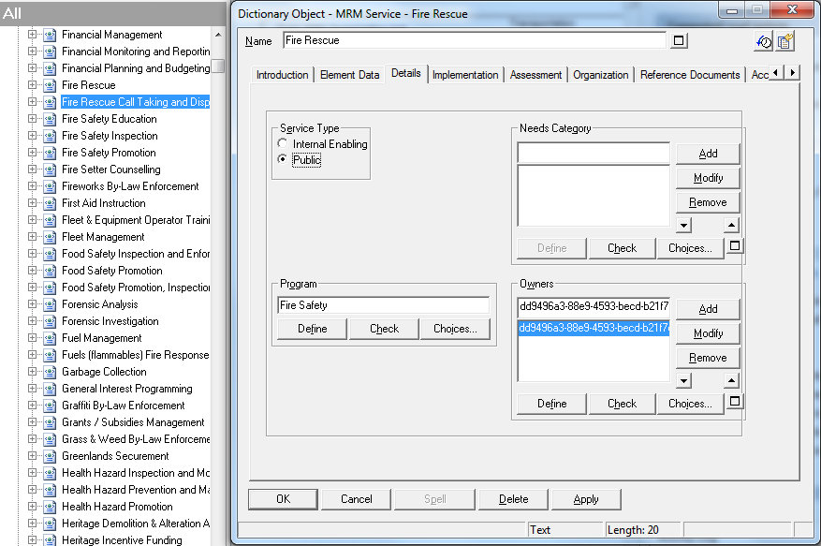
- The properties of a Service are organized in different groups
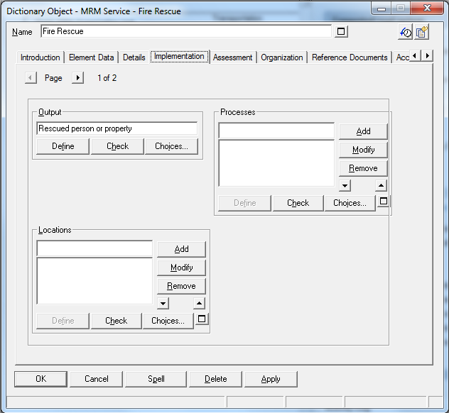
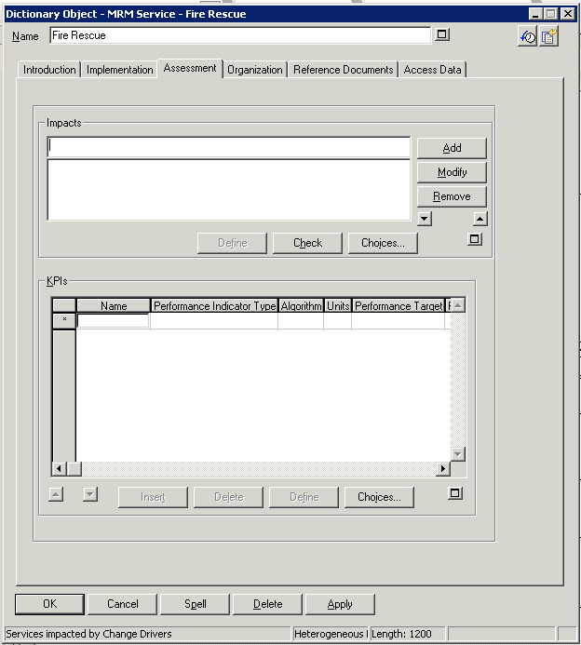
- Edit the Fire Rescue service description
- Set the Service Type to Public
- Set the service to a new output: “Rescued person or property”
- Click the Define button to navigate to the “Rescued person or property” output
- Edit the output description
- Set the output type to Service
- Set the Service Output Type to Interventions
- Set the output’s outcome to the existing “Reduced loss of property from fire” (this requires creating a new MRM Service Value)
- Add a new output outcome “Reduced loss of life from fire”
- Navigate to the “Reduced loss of property from fire” outcome and show that its target group is “Home Owner”
- Navigate to the new “Reduced loss of life from fire” outcome and set its target group to “People involved in fires”

You can also edit properties using the Properties view. Select View > Properties. Select a definition to view and edit its properties.
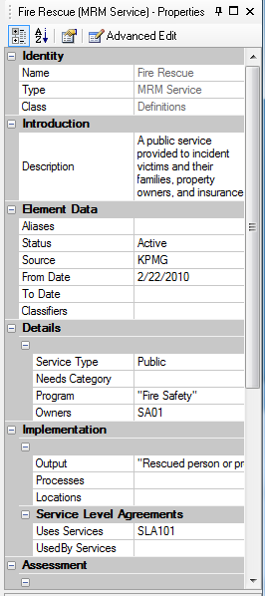

Editing relationships
Relationships are modeled using definition properties in System Architect that refer to other definitions. There are also cases where the relationship itself can have properties and has referencing properties for its ends. Relationships can be “mirrored” so that the can be navigated from either direction.
Since relationships are modeled with properties, the definition dialogs can be used to create, update or delete relationships. Definition dialogs that display relationship properties can use the name of the related item to navigate to that item, opening the its definition dialog. As shown in the previous activity, many definition dialogs can be opened displaying a complex chain of relationships that can be edited along the way.

Relationships can also be edited using diagrams. Relationships are usually depicted with lines that represent a particular relationship property or definition. Double click on the line to open the relationship definition.

Finally, relationships can be viewed and edited using matrices, which provide a convenient way to edit a number of related elements very quickly, and to easily see where relationships might be missing.

- Open the Matrix Browser and click on the MRM pane.
- Open the Program administers Services matrix
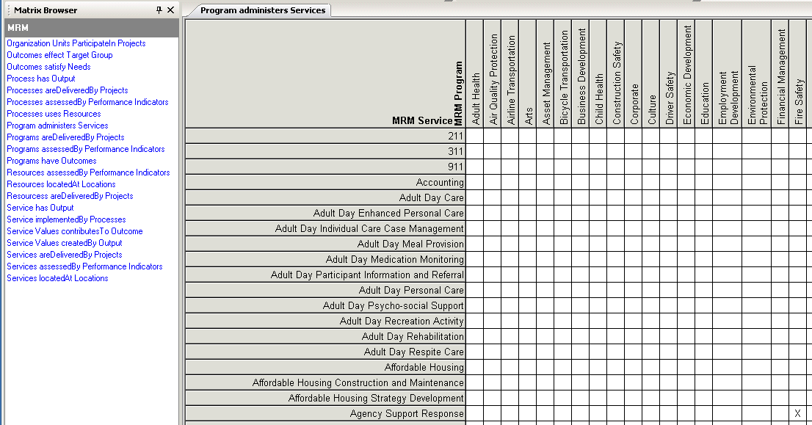
- Select the programs and services that comprise the scope of the matrix
- Note that these scopes can be saved and opened from the Saved matrices pane
- Various fire services are administered by the “Fire Safety” program
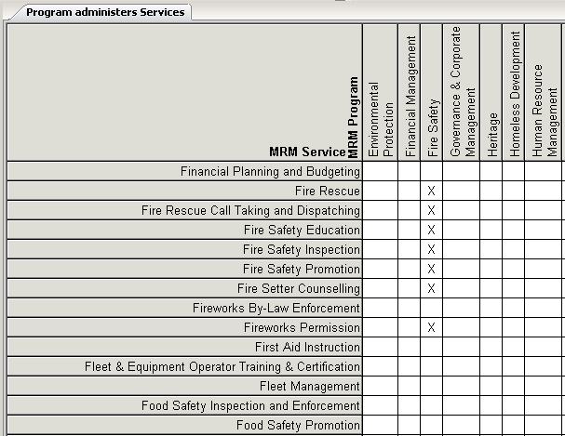
- Note that “Fire Safety Promotion” is not administered by any program. Click in the cell to indicate it should be administered by the “Fire Safety” program
- Definitions represented by rows and columns can be created, edited and/or deleted from the matrix as well
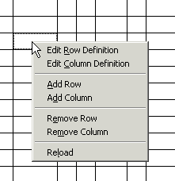

Displaying related model elements
Sometimes it is convenient to quickly see all the elements related to a given element, and to be able to browse the definitions of those elements. One way to review related elements is to use the Relations view.

- Open the “Fire Rescue” service
- Click on the References button to see the all the references to/from “Fire Rescue” in the model.
- In the References view that is displayed, expand MRM Program and double-click on “Fire Safety” to display its properties
- Note that “Fire Safety” appears twice in the list since “Fire Rescue” refers to its administering program, and the program in turn refers to the services its administers (through the “mirrored” properties), indicating the relationship is navigable in both directions.
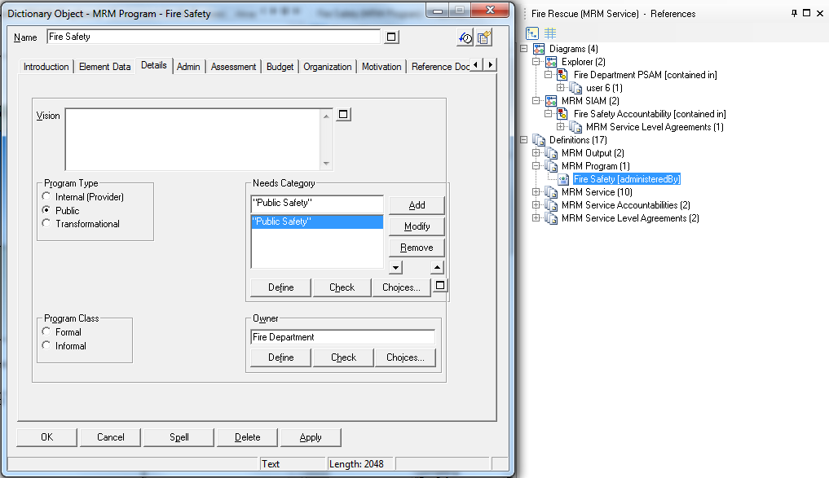

The second way to view relationships is with an Explorer Diagram

- Create an Explorer diagram and drag-and-drop the “Fire Department” organization unit on the diagram
- Select Fire Department and Show Immediate Relatives
- Show how this can be used to navigate relationships in the model showing all related elements
- Select Hide Relationship Lines not attached to the Selected Object
- Show how this can be used to facilitate impact analysis of change
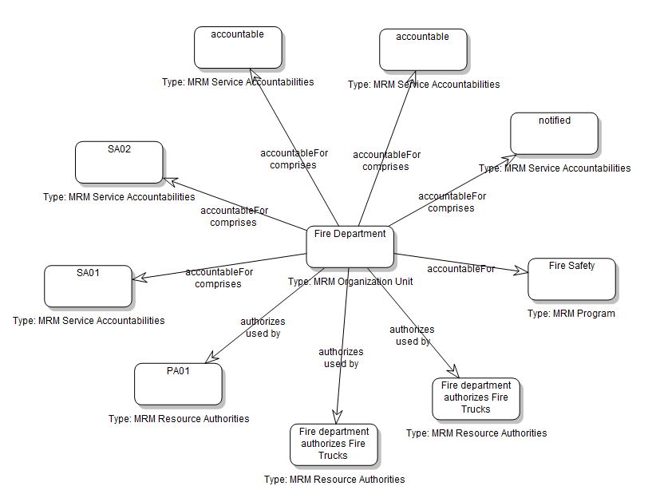

Using MRM Diagrams
MRM-specific diagrams can be used to show and edit relationships between model elements graphically. This can be a very effective way of visualizing elements in the municipal model, communicating the relationships and their business implications to stakeholders.

- Open the “Fire Department” SIAM diagram. This diagram shows the accountability chain from organization units to the programs they are accountable for to the services administrated by the programs to the target groups whose needs are addressed by the service.
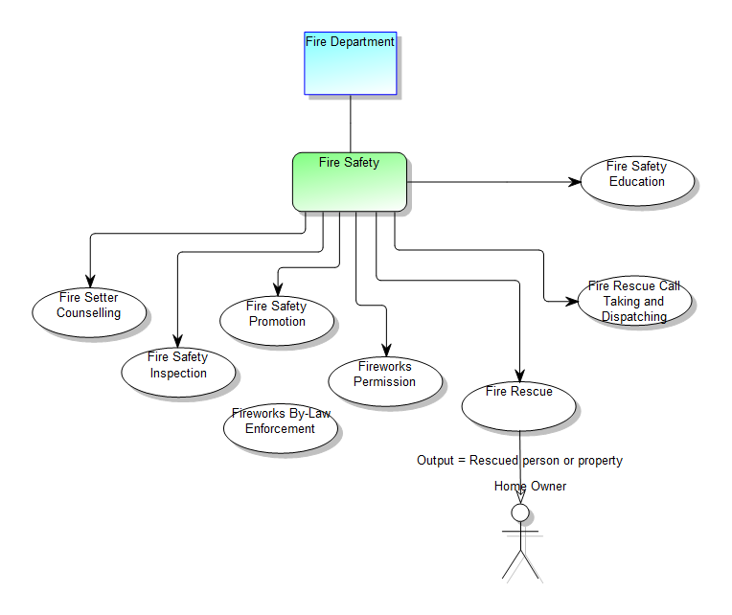
- Demonstrate how to add new entities and relationships to the model from the diagram
- Demonstrate how to move items on the diagram and arrange lines
- Demonstrate Zoom
- Demonstrate show/hide relationship lines
- Demonstrate mouse-over highlighting
- Discuss diagram and symbol formatting using the Format menu.
- Discuss how to use format files to save customized diagram and symbol formatting, and how format files can be used to address stakeholder viewpoints.
- Show editing an entity or relationship from the diagram

Controlling model elements and relationship displayed in diagrams
Model Elements can easily be added to or removed from a diagram through the following techniques:
- Elements can be dragged from the Explore onto a diagram. If the diagram supports the element, it will be depicted on the diagram with the appropriate symbol.
- Right-click in empty space in the diagram and select Choices. The model elements that can be depicted on that diagram are displayed. Drag-and-drop elements from the choices list to the diagram.
- Drag-and-drop an Explorer Object or Explorer Relationship report onto a diagram to add elements selected by the report that are allowed on the diagram. Note: The relationship lines added are not refreshed when the entities and relationships in the database are updated or deleted. To refresh the diagram, select all the elements of type Relationship (the ones added by the explorer relationship report) remove them from the diagram, and then use the explorer relationship report to put back the updated relationship lines.
- Select any node symbol on the diagram and press the delete key to remove the symbol from the diagram, or purge (i.e., delete) the represented entity from the repository
- To remove a line from the diagram, select the line and invoke Hide Selected <type> Relationship Lines… To purge the line from the encyclopedia, delete the line.
- To get the hidden lines back, right click in empty space on the diagram and select Hide Selected Relationship Lines… Deselect any hidden lines you wish to see.
- You can also select a node symbol and invoke Isolate Selected Symbol And Attachments to remove all symbols and lines from the diagram except those that are selected. This might be useful if an Explorer Object Report added too many symbols to the diagram.

Creating Hierarchy Diagrams
Many elements in the MRM metamodel can be organized in hierarchies. These include Organization Unit, Program, Service, Process, Resource, Need, Outcome, Output, and Target Group. These hierarchies are created by setting the appropriate properties, each of which starts with “Sub-”.

- Open the “City Manager’s Office” Organization Unit definition and show the Sub-Organization Unit property.
- Show the Organization Unit report
- Create an MRM Hierarchy Diagram
- Drag and drop the “City Manager’s Office” Organization Unit on the diagram. The organizational hierarchy is automatically drawn and formatted.
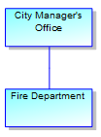

Querying, validating, and reporting on model content
Besides simple search, it is also possible to quickly write reports that present information in the model. Reports can use diagrams, symbols or definitions as data sources, and can filter based on complex expressions involving property values and relationships to other entities.

Reports can be used to find matching elements in the model, or to validate elements by showing elements whose properties have missing or invalid values.

The MRM comes with a set of reports already created that support the functions and operations of the business use cases and their tasks.

- Open ReportsReport Generator… and ensure the MRM Reports.RPT file is open. This report file contains all the reports that are applicable to the MRM
- Generate the Program Administers Services report
- Show how the programs and services in the report view can be opened to display their details
- Generate the Programs administering no Services report
- Generate the Services with no administering Program report
- Show how the Program Administers Services report was created

Creating and Applying Analytics and Heat Maps
Stakeholders use various views to capture, communicate, validate, and reason about elements that address their particular concerns. Understanding and reasoning about models is facilitated through analytics that can report on specific elements in the model, and depict assessments against criteria on the model diagrams. Users can use the Heat Map Manager to easily choose the analytics they wish to display.

- Open the Transportation PSAM Explorer diagram
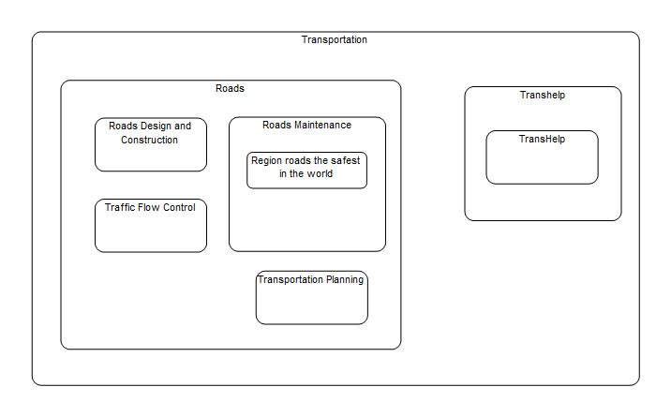
- Open the Heat Map Manager view and select all the analytics for Congested road system
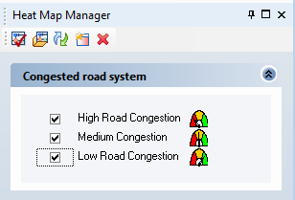
- Click the check box in the view toolbar to apply the selected analytics
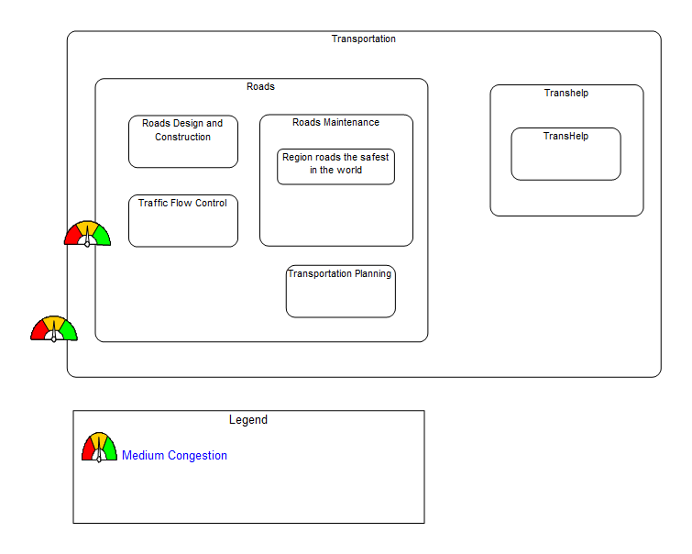

Publishing the municipal model
Business analyst will usually access the municipal models through the System Architect rich client, providing them with full access to the model elements, diagrams, reports, etc. Some business analysts and more business users with limited editing needs may use System Architect/XT to explore the municipal models and make simple changes to the model elements.

A broader community of business users will also benefit from the ability to browse the model, reason about its contents, determine if there are contradictions, missed objectives, or any number of other activities that could lead to effective action. These users generally don’t need to, or do not have permission to, edit the model. They may also be occasional users who do not need to invest the effort to become proficient at using municipal model editing tools, possibly even System Architect/XT. For these users, navigating a read-only published model on the web may be sufficient.

System Architect Publisher can be used to publish parts of, or the complete municipal model to the Web making it accessible through a collaboration site for a broad range of municipal users.

- Start SA Publisher and open the MRM.xml publisher configuration file
- Show how the model would be published to the Web
- Demonstrate the results of a published model in a Web browser

Publishing MRM method work products
The outputs of a municipal modeling engagement/project are the work products of the method. These work products consist of the models themselves, the models as published to collaboration sites, and the published reports and documents specified by the method. It is trough these published work products that the broader municipal community, administering officers, and commissions achieve value from the modeling activities.

System Architect provides a number of facilities for generating publish-quality work products from information in the model. Some of these facilities are focused on the creation of Web resources that are accessible by a broad community:
- HTML documents created by the Report Generator (instead of grid views in System Architect)
- HTML reports of selected documents and definitions
- HTML documents created by SA Publisher

Others tools provide publishable documents that may be for printed distribution:
- Word Reports
- Rational Publishing Engine

Still others are oriented around support for business intelligence and integration with other data sources:
- Rational Insight
- Cognos Reports

The SDW supports a number of publishable work products as specified by the method:
- Organization Unit Profile: a report that lists all organization units and their properties
- Program Profile: a report that lists all programs and their properties
- Service Profile: a report that lists all services and their properties

- Demonstrate the creation of a Organization Unit or Program Profile

Customizing the metamodel
The MRM is a highly customizable metamodel that can easily be extended to capture properties that address specific municipal needs. System Architect is designed specifically for extensibility with the ability to:
- Define new diagrams, symbols, entity definitions, properties and relationships
- Customize the dialogs for viewing and editing entity and relationship properties
- Create custom browsers to organize model content for particular stakeholder viewpoints
- Create matrices for editing new relationships
- Create reports to query, validate and communicate municipal model content
- Create reports for new method work products
- Create format files that specify diagram and symbol formats.

- Show the MRM USRPROPS.TXT file and discuss how new diagrams, symbols and definitions are created

Backing up and restoring a municipal model
Municipal models represent valuable assets that influence municipal strategic planning that can result in significant community impact – these models can affect peoples’ lives. It is therefore important to properly preserve, manage, and govern these models, and make them accessible to stakeholders for reuse.

It is also important that the municipal models be properly secured as they can contain sensitive information that must be carefully handled. Flexible authentication and access control supporting municipal governance principles is a must.

- Show how to use the Encyclopedia Manager to backup and restore municipal models
- Show how database security is supported through roles and access control using the SAEM and SA Catalog Manager

Managing User Access
It is also important that the municipal models be properly secured as they can contain sensitive information that must be carefully handled. Flexible authentication and access control supporting municipal governance principles is a must. Users can be authenticated for:
- Access to the SDW
- Encyclopedia access
- Enterprise Encyclopedia access through SA/XT
- Access to collaboration sites

Access to the SDW
Users can access an installation of the SDW either on a local machine or through Remote Desktop Connection access to a virtual image in a supported Cloud. This access would be applicable for business analysts who are maintaining the MRM itself, editing a municipal model, running reports and work product generation tools, and customizing or extending the MRM.

Encyclopedia Access
Once users are logged into the host operating system, either on a local machine, or through Remote Desktop Connection to a virtual image in a cloud, they can run Rational System Architect, one of the primary tools in the SDW. When System Architect is started, the user is prompted to open an encyclopedia. The encyclopedia can be on the local machine (or in the local virtual image), or it can be a shared encyclopedia in a LAN connected to the user’s machine. When using a shared encyclopedia in a LAN, each user must be authorized to:

- Login to the computer or virtual image where the shared encyclopedia is located
- Invoke Start > All Programs > IBM Rational > IBM Rational Lifecycle Solutions Tools > IBM Rational System Architect > SAEM for SQL Server
- In the SAEM, Invoke Server > Connect… to connect to the desired server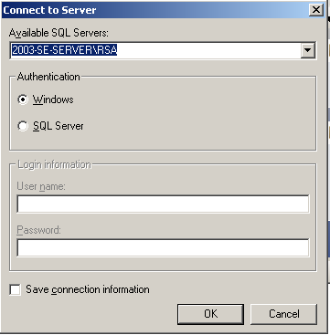
If you have already previously connected to this server, it will be available as a quick link in the SAEM Tasks view
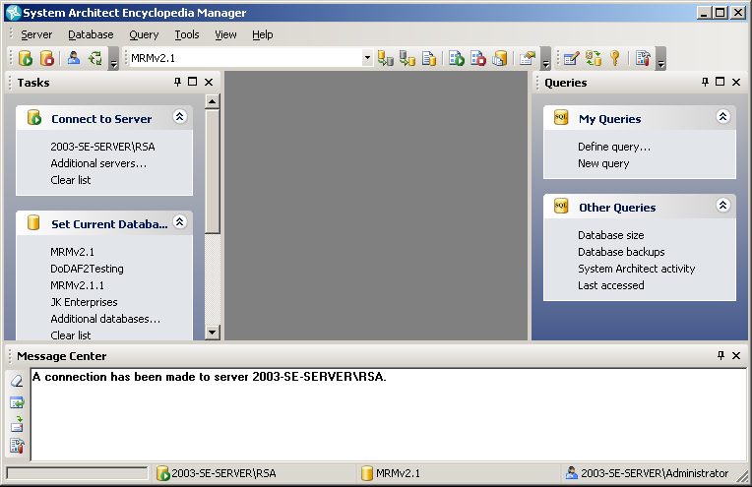
- Select the database you wish to manage. The databases available from the connected repository are listed from the drop-down in the middle of the toolbar.

Enterprise Encyclopedia Access
Enterprise encyclopedias are used to support access through SA/XT. These encyclopedias, due to their broader availability, require richer access control facilities. SA/XT access would be applicable for business analysts making limited updates, and business users who need mostly read-only access to the municipal model.

  - Access to the SA encyclopedia for those users who will be using the shared MRM encyclopedia using the SA rich client
  - Add users, roles and permissions to an enterprise encyclopedia using the SA Catalog Manager

Collaboration Site Access
Access to the Quickr collaboration site and places where municipal models and related work products and documents have been published.

  - MRM Collaboration Site
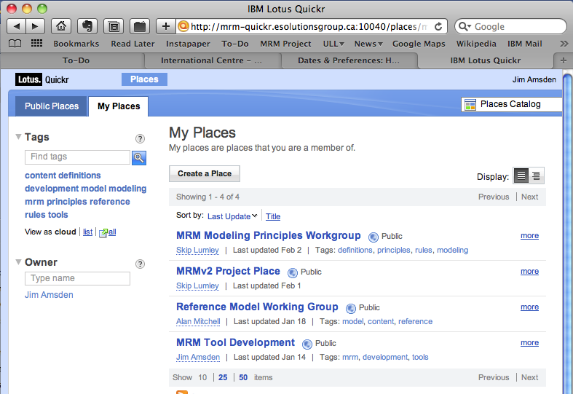

Municipal model versioning and lifecycle management
Municipal models are constantly evolving to address business influencers and changing environments and needs. Each municipality that uses the MRM will potentially discover specific target group needs that require new programs and services that were initially unique to their situation, but may later be discovered to be applicable to other communities. The value of the MRM can therefore grow over time by harvesting and reusing model content and best practices that are discovered over time. Making changes to municipal models, whether they are changes within a single community exploring different solution opportunities, or changes to the shared reference model itself require rich facilities for lifecycle management consistent with governance policies and principles.

System Architect provides a number of features that can be exploited to support lifecycle management and governance of municipal models.
- The MRM itself, and different municipal models that are instances of the reference model can be saved as backup files for future use. These files can be stored in a version management system such as Rational Team Concert, and made available to potential users through asset management facilities such as Rational Asset Manager.
- Encyclopedia databases can have change management enabled, which allows the database to record changes in all model elements.
- Users can create workspaces in an encyclopedia database that can be used to separate work streams, enable parallel modeling activities, explore different opportunities, and compare and merge different work streams.
- Users can checkout part of the model elements and work on them in their own private encyclopedia, possibly disconnected from the network. When they are done, they can check their changes back in and be assured that there will be no collisions in the database.
- Encyclopedias can be detached from one server and attached to another to work more collaboratively in a different location. Then the encyclopedia can be re-attached to the shared database for broader use.

These are all standard Rational System Architect features that are described in greater detail in the on-line help.

